
Visual Scenario Generator (VSG) v4.1 Installation and Configuration Guide

Contents

Overview 1
VSG System Requirements 1
Installing the VSG 1
Setting up the SQL Server 2005 Express Database for the VSG 5
Installing SQL Server with the VSG installer 5
If SQL Server is Already Installed on Your Machine 7
Installing SQL Server Management Studio (Suggested) 7
Modifying Your SQL Server Express Service (Suggested) 7
Modifying Your “sa” Password (Optional) 8
Creating a new SQL Server Logon (Suggested) 8
Starting the VSG 10
Upgrading the VSG 10
Troubleshooting 11
1. When running the VSG, I get an “Error initializing database: CREATE DATABASE failed” error. 11

Overview
To install and configure the VSG product, complete the following tasks:
- Understand the VSG system requirements.
- Install Microsoft’s SQL Server 2005 Express, if it is not already installed.
- Install the VSG on your PC.

Ideally, the VSG will be installed on a PC on which the DDD Server already is installed. This will allow you to easily create, modify, and import scenarios into the VSG that you are running with the DDD Server.

VSG System Requirements
The minimum system requirements for installing the VSG include:
- Windows XP with Service Pack 2 (SP2)
- Pentium 4 (2.0 GHz processor or equivalent)
- CD-ROM drive
- 400 MB available hard drive space
- 1 GB RAM
- VGA graphics card, 128 MB
- SQL Server 2005 (Express edition or higher)
- Microsoft’s .Net 2.0 Software Development Kit (SDK) – Optional, only needed if you plan on modifying or creating an image library
- Microsoft DirectX 9.0 or higher, additionally the DirectX August 2007 Re-distributable software (included with this installer)
- Requires Administrator Privileges during installation

In addition to the above minimum requirements, the following requirements are recommended:
- Dual-core Pentium 4 (3.2 GHz or equivalent)
- Microsoft SQL Server Management Studio Express (see: Installing SQL Server Management Studio)

Installing the VSG
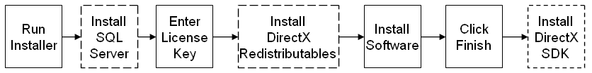
Dotted lines represent optional actions or actions that might not occur given your system configuration.
Use the following steps to install the VSG:
- Insert the CD. The VSG installation should start automatically and display the Welcome to Setup screen (below. If the CD does not run automatically, open the My Computer folder, right click on the CD ROM drive, and select AutoPlay.

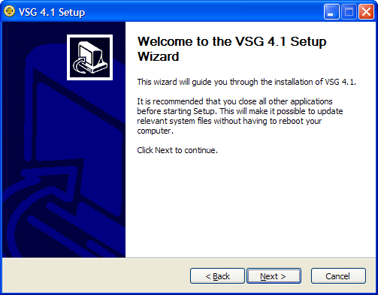
- If you do not have SQL Server 2005 installed on your machine, follow the steps outlined below in Installing SQL Server with the VSG installer.
- If you do not have the August 2007 DirectX redistributable libraries installed, the installer will install them for you. Click Next.
- Once SQL Server 2005 Express is installed, the License Key screen is displayed (below). Enter the 32-digit license key given to you by Aptima and click Verify Key. Once the key has been verified, click Continue. If you do not have a license key, or if the key is invalid, please contact Aptima’s customer support at support@aptima.com and request a new key.

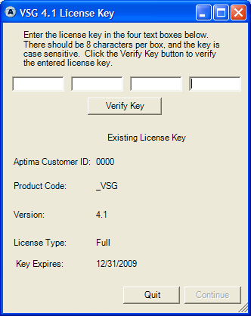
- The VSG 4.1 license agreement is displayed. Read the agreement and select the “I agree” button.
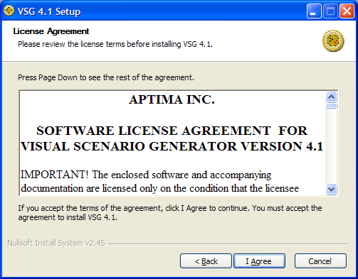
- In the Choose Install Location window, click Next to install VSG in the default location.

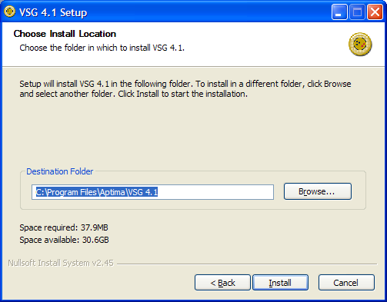

- A progress window is displayed during the installation (below).
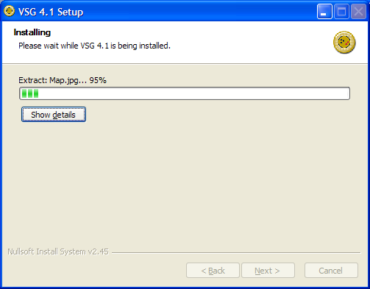
- Upon successful installation, the “Completing Setup” screen is displayed, as shown below.
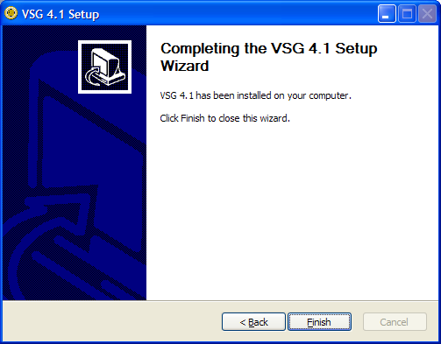
- Click Finish to complete the installation.

Setting up the SQL Server 2005 Express Database for the VSG

Installing SQL Server with the VSG installer
This installer will install SQL Server 2005 Express on your machine if you do not already have this application installed. This is seen in Step 2 above. Installing SQL Server 2005 Express requires that you have administrative privileges on the system. To successfully install SQL Server 2005, follow these steps:

- Click Next in the installer windows until you reach the Registration Information screen. Enter your name/company (optional), and make sure the “Hide advanced configuration options” checkbox is unchecked. Click Next.
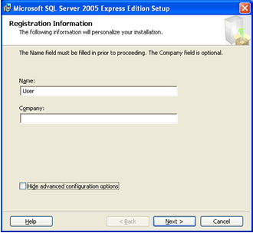
- Click Next until you get to the Service Account screen. For the “SQL Server” service, select “Local System” from the drop down box. Then click Next.
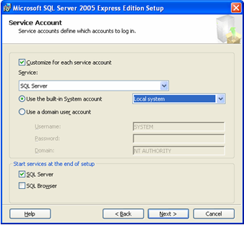
- Continue clicking Next until you reach the Authentication Mode screen. Select the “Mixed Mode” radio button, and specify your “sa” logon password.
NOTE: It is important to write this password down, as it is your SQL system administrator account.
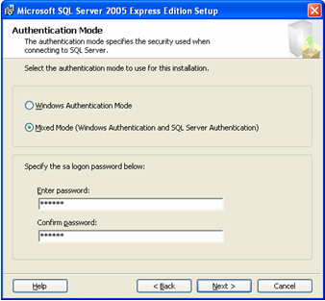
- Continue clicking Next until you reach the end of the SQL Server 2005 installer. Click Finish.

If SQL Server is Already Installed on Your Machine
If your computer already had SQL Server 2005 installed on it, then you need to make sure that the SQL Server Express Service is controlled by a user account which has write permissions. You can view which account has control of this service by following the steps in Modifying Your SQL Server Express Service. By default, the “NetworkService” account is specified for this service, and this account does not have write permissions. Select the “Local System account” radio button, on the Log On tab of the “SQL Server Properties” dialog box. The Local System account has write permissions. We also suggest that you create a specific SQL Server account for logging into the VSG. Refer to Creating a new SQL Server Logon for information on how to do this.

Installing SQL Server Management Studio (Suggested)
Installing SQL Server Management Studio requires that you have administrative privileges on the system. You can retrieve the installer from http://www.microsoft.com/downloads/details.aspx?FamilyId=C243A5AE-4BD1-4E3D-94B8-5A0F62BF7796&displaylang=en#filelist. If you on a 64-bit operating system, download the ”SQLServer2005_SSMSEE_x64.msi” installer, otherwise download the “SQLServer2005_SSMSEE.msi” installer. Run the installer. Once installation is complete, you can access the Management Studio from Start Menu -> Programs -> Microsoft SQL Server 2005 -> SQL Server Management Studio Express.

Modifying Your SQL Server Express Service (Suggested)
Modifying system services requires that you have administrative privileges on the system. To open the Services dialog, click Start Menu -> Settings -> Control Panel -> Administrative Tools -> Services. From the panel on the right, locate the entry for “SQL Server (SQLEXPRESS)”. Double click this entry. This will open the “SQL Server Properties” window. From the Log On tab, you can modify the account used to log on to this service. It is suggested that you select the “Local System account” radio button, however selecting any account which has write permissions will suffice.

Modifying Your “sa” Password (Optional)
Log on to SQL Server Management Studio. From the navigation panel on the left, select Security -> Logins. Right click on the “sa” user, and click “Properties”. Modify the two password fields with your updated passwords.

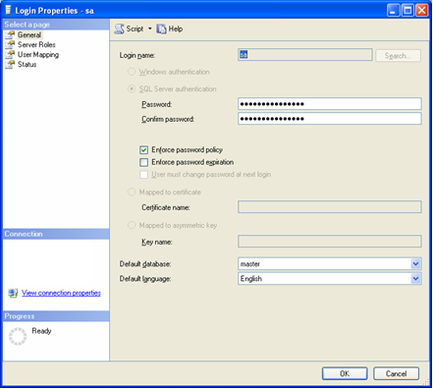

Click OK. This user account can now be used to log into the VSG.

Creating a new SQL Server Logon (Suggested)
Log on to SQL Server Management Studio. From the navigation panel on the left, select Security -> Logins.

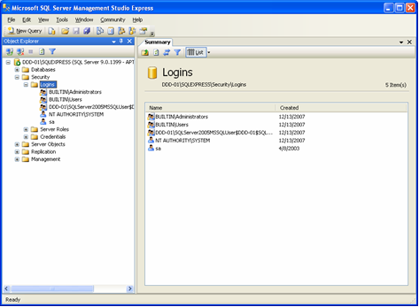

Right click on the Logins folder, and select “New Login…”. Enter your Login name, select the “SQL Server Authentication” radio button, then enter your password into the password fields.

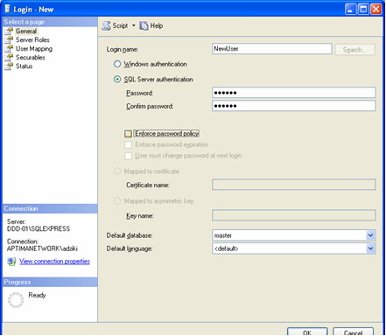

Select “Server Roles” from the list on the left, and select “sysadmin”.

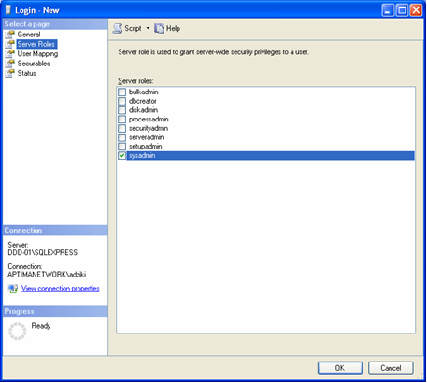

Click OK. This user account can now be used to log into the VSG.

Starting the VSG
The VSG can be started two ways:
- On the Desktop, locate and double click the “VSG 4.1” icon (  ).
- From the Start Menu, click Programs, Aptima, VSG 4.1, and then click the VSG 4.1 icon.
NOTE: It is important that you are not viewing the VSG database with any tools when you are starting the VSG, creating a new scenario, or importing an existing scenario. If another application is viewing the database when you are doing any of these actions, you will get a “DB Initialize” error.

Upgrading the VSG
As new versions of the DDD are released so to will new versions of the VSG. If you have an installer for a version of the VSG which is newer than your currently installed software, upgrading is simple.
- Insert the CD. You should see the following “Aptima VSG 4.1” dialog.
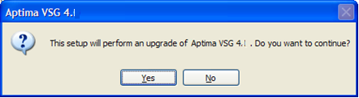
- Click Yes.
- This will lead you to Step 2 from Installing the VSG. Continue along the steps above until your upgraded product is fully installed.
NOTE: Make sure that you read the Release Notes that come with your upgraded software. This document is a helpful outline of new changes made to the VSG.

Troubleshooting

When running the VSG, I get an “Error initializing database: CREATE DATABASE failed” error.
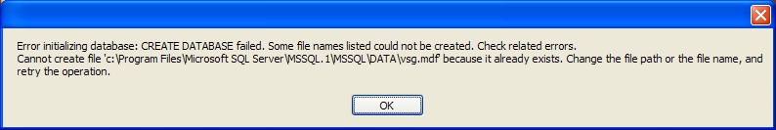
This error usually occurs when the “vsg.mdf” file exists in the SQL Server’s Data directory, but SQL Server does not know that it exists. To correct this, you should open up SQL Server Management Studio Express, right click on the Databases node on the left, and click “Attach…”. Beneath the “Databases to Attach” list box, click the “Add…” button. Browse to the location of the vsg database, and click OK. Then click OK for the “Attach Databases” window. Try to re-run the VSG.

